# Topic Is -- Init wsgi and asgi Files in Django.

# 

The folder which contains **__init__.py** file is considered as python package.

**__init__.py**

# Note: asgi Synchronous or Asynchronous provide in application future.

# import os : Importing os module.

# from django.core.asgi import get_asgi_application : Importing function from asgi module

# os.environ.setdefault('DJANGO_SETTINGS_MODULE', 'home.settings') : Defining setting module to environment variable.

# application = get_asgi_application() : This function returns asgi callable. [Application is object]

from django.core.asgi import get_asgi_application

# os.environ.setdefault('DJANGO_SETTINGS_MODULE', 'home.settings')

A mapping object representing the string environment

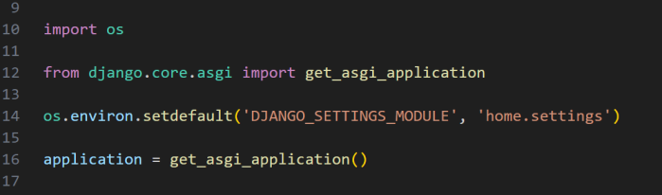

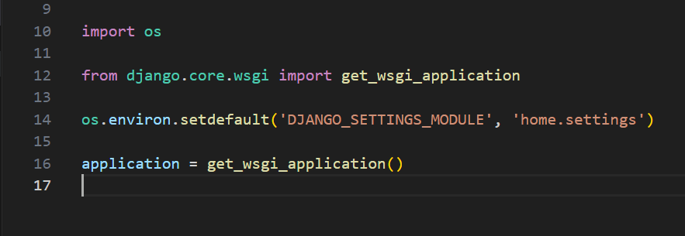

**Note :** asgi Synchronous provide in application future.

**import os :** Importing os module.

**from django.core.wsgi import get_wsgi_application :** Importing function from wsgi module

**os.environ.setdefault('DJANGO_SETTINGS_MODULE', 'home.settings') :** Defining setting module to environment variable.

**application = get_wsgi_application() :** This function returns asgi callable. [Application is object]

from django.core.wsgi import get_wsgi_application

A mapping object representing the string environment

os.environ.setdefault('DJANGO_SETTINGS_MODULE', 'home.settings')